Number of Autosomes present in humans:
A. 38
B. 40
C. 42
D. 44
ANSWER: D
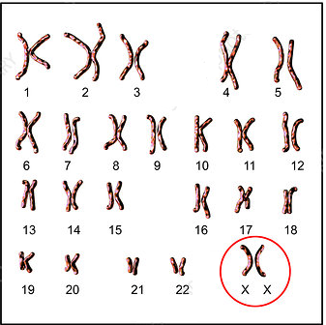
Observe the diagram and select the best answer from the given options:
A. Karyotype of human female
B. Karyotype of human male
C. Karyotype of drosophila male
D. Karyotype of drosophila female
ANSWER: A
The human female possesses a genotype of:
A. 40+XY
B. 44+XX
C. 44+XY
D. 42+XY
ANSWER: B
The human male possesses a genotype of:
A. 40+XY
B. 40+XX
C. 45+XY
D. 44+XY
ANSWER: D
Sex determination in Drosophila was done by:
A. T.H.Morgan
B. Rudolf Virchow
C. Bateson
D. Gregor John Mendel
ANSWER: A
When red-eyed female (X^{R}X^{R}) is cross with white eyed male (X’Y) the F₂ generation show red-eyed and white-eye, this is ratio of:
A. 4:1
B. 1:1
C. 1:3
D. 2:1
D. 3:1
ANSWER: D
Drosophila melanogaster is a common
A. Fruit fly
B. Bee
C. Wasp
D. None of these
ANSWER: A
T.H Morgan noted that the male and female Drosophila have difference in the
A. Chromosomes
B. Reproduction
C. Cell division
D. None of these
ANSWER: A
Sex determination in Drosophila was done by:
A. T.H.Morgan
B. Rudolf Virchow
C. Bateson
D. Gregor John Mendel
ANSWER:

Observe the diagram and select the best answer from the given options:
A. Karyotype of human female
B. Karyotype of human male
C. Karyotype of drosophila male
D. Karyotype of drosophila female
ANSWER: D
______ pairs of chromosomes found in Drosophila:
A. Two
B. Three
C. Four
D. Five
ANSWER: C
Which of the following is/are sex-linked disorders of man?
A. hemophilia
B. color blindness
C. muscular dystrophy
D. all of these
ANSWER: D
XY-XX pattern of sex determination is found in
A. drosophila
B. man
C. both a and b
D. none
ANSWER: C
XO-XX pattern of sex determination is found in
A. grasshopper
B. protenor bug
C. both a and b
D. none
ANSWER: C
WZ-ZZ pattern of sex determination is found in
A. birds
B. butterflies
C. moths
D. all of these
ANSWER: D
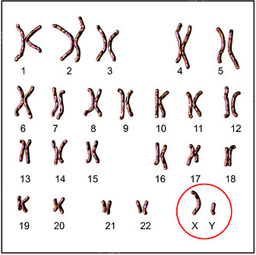
Observe the diagram and select the best answer from the given options:
A. Karyotype of human female
B. Karyotype of human male
C. Karyotype of drosophila male
D. Karyotype of drosophila female
ANSWER: B

